CHAPTER

# 7 THE KINGDOM )OR PROTOCTISTA(

PROTISTA

*Animation 7.1: Kingdom Protista*

[*Source & Credit:*](http://anatomyeshs.wikispaces.com/Ch.16+Respiratory+System) [*media.giphy*](http://media.giphy.com/media/AYPX6JBP8P12U/giphy.gif)

1

The Kingdom Protista consists of a vast assortment of primarily aquatic eukaryotic organisms whose diverse body forms, types of reproduction, modes of nutrition and lifestyles make them diicult to characterize. Basically, this kingdom is deined by exclusion i.e., all members have characteristics that exclude them from the other four kingdoms.

All protists are eukaryotic and have evolved from prokaryotes. Another reason for creating a separate kingdom arises from the diiculty in placing certain eukaryotic organisms in the appropriate kingdom. This diiculty is a consequence of the fact that the other eukaryotic kingdoms have their evolutionary origin in kingdom Protista. The other eukaryotic kingdoms Plantae, Fungi, and Animalia arose from protists in various ways.

The protists are unicellular, colonial or simple multi cellular organisms that possess a eukaryotic cell organization. Eukaryotic cells, the unifying feature of protists, are common to complex multicellular organisms belonging to the three eukaryotic kingdoms (Fungi, Plantae and Animalia) but clearly diferentiate protists from members of the prokaryotic kingdom (Monera). Unlike plants and animals, however, protists do not develop from a blastula or an embryo.

The kingdom protista contains four major groups of eukaryotic organisms which are : single celled protozoans, unicellular algae, multicellular algae, slime molds and oomycotes.

## HISTORICAL PERSPECTIVE

In 1861, John Hogg proposed the kingdom Protoctista for microscopic organisms. In 1866, Ernst Haeckel suggested creating the Kingdom Protista to include bacteria and other microorganisms (such as *Euglena*) that kingdom. He, however, separated blue green algae and bacteria (prokaryotes) from nucleated protists and placed them in a separate group he called Monera, within the kingdom Protista.

In 1938, Herbert Copeland elevated the prokaryotes to kingdom status, thus separating them from Protista. In ive kingdom system of Robert Whittaker (1969) only unicellular eukarayotes were placed in kingdom Protista. Currently this kingdom also includes colonial and simple multicellular eukaryotes as well. Margulis and Schwartz (1988) modiied the ive kingdom system. Protista or Protoctista is one of the ive kingdoms.

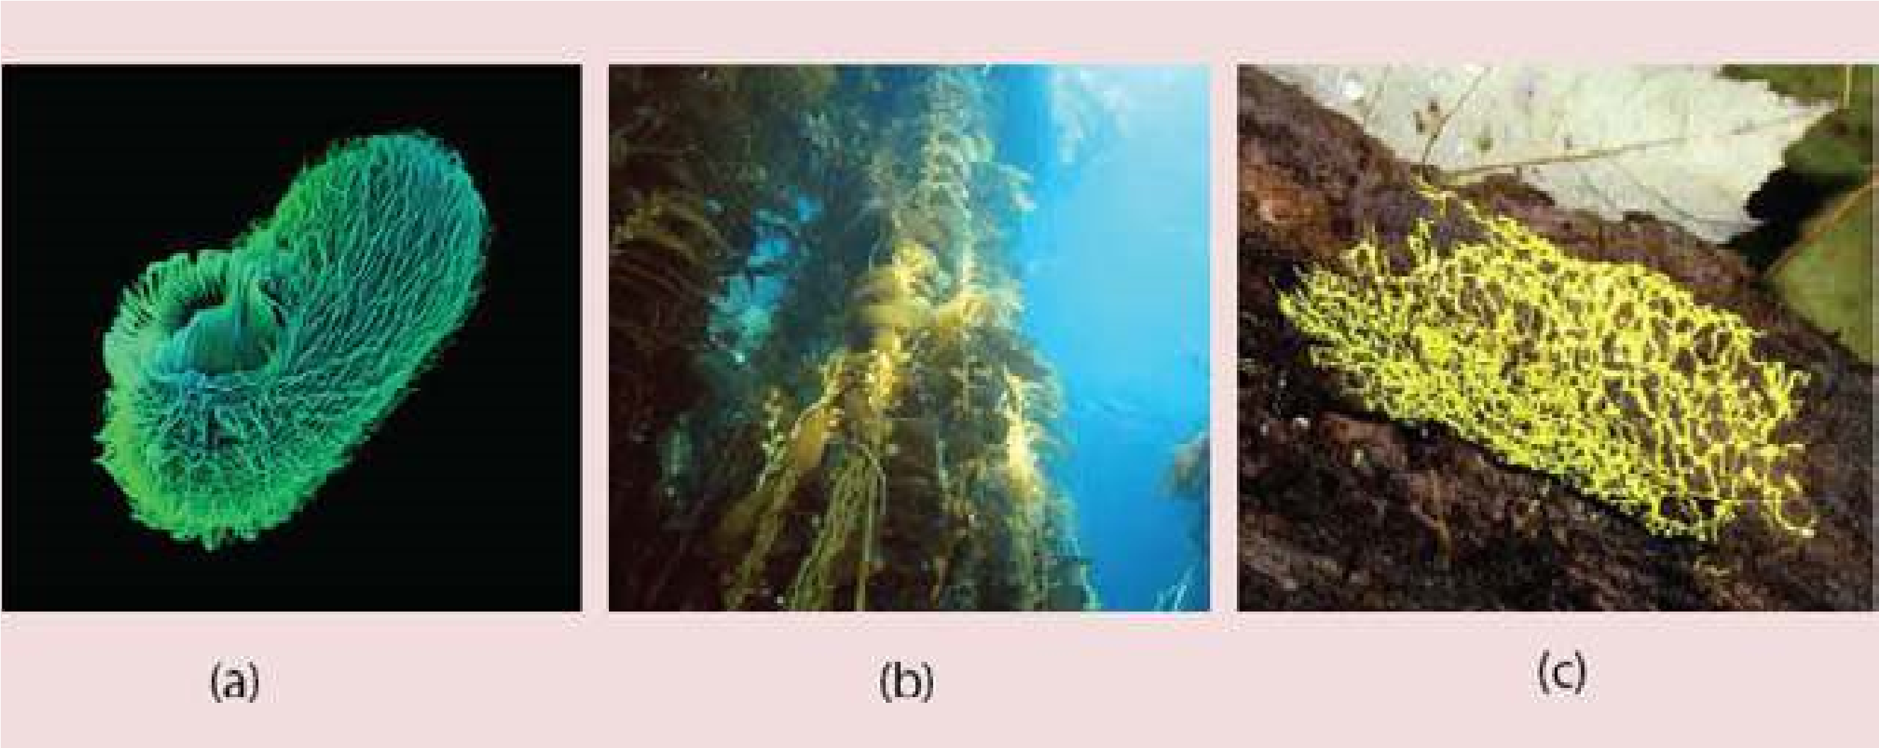

*Fig 7.1 The kingdom protista includes such diverse species as (a) single celled ciliated protozoan, (b) giant brown algae (kelps) and (c) slime molds.*

## DIVERSITY AMONG PROTISTA

During the course of evolutionary history, organisms in the kingdom protista have evolved diversity in their (a) size and structure, (b) means of locomotion, (c) ways of obtaining nutrients, (d) interactions with other organisms, (e) habitat and (f) modes of reproduction. Diversity is exhibited by all of the major protist groups (Fig. 7.1).

Based on the diversity, most biologists regard the protists kingdom as a polyphyletic group of organisms; that is, the protists probably do not share a single common ancestor. Margulis and Schwartz have listed 27 phyla to accommodate this diverse assemblage of organisms.

## MAJOR GROUPS OF PROTISTA

### 1. Protozoa : An imal - like Protists

All protozoans are unicellular. Most ingest their food by endocytosis. A summary of protozoan diversity is given in Table 7.1.

Table 7.1 Some groups of protozoa

|  |  |  |  |
| --- | --- | --- | --- |
| **Common Name** | **Form** | **Locomotion** | **Examples** |
| Amoebae | Unicellular, no deinite shape | Pseudopods | *Amoeba, Entamoeba,* |
| Zoolagellates | Unicellular. some colonial | One or more  Flagella | *Trypanosoma, Euglena,* |
| Actinopods | Unicellular | Pseudopods | Radiolarians |
| Foraminifera | Unicellular | Pseudopods | Forams |
| Apicomplexans | Unicellular | None | *Plasmodium* |
| Ciliates | Unicellular | Cilia | *Paramecium, Vorticella. Stentor* |

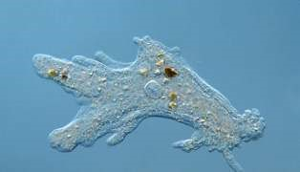**(a) Amoebae:**

This group includes all free living freshwater, marine and soil amoebae as well as those that are parasites of animals. Amoebae lack lagella and move by forming specialized cytoplasmic projections called pseudopodia (false feet). (Fig. 7.2).

The intestinal parasite, *Entamoeba histolytica*, causes; amoebic dysentery in humans.

Fig. 7.2 The lowing pseudopods of Amoeba constantly change shape as the

*Animation 7.2: Amoeba*

*Source and Credit:*

*Gifsou*

[*p*](http://gifsoup.com/index.php)

organism moves and feeds.

**The Giant Amoeba**

The giant amoeba *Pelomyxa palustris* may be the most primitive of all eukaryote like forms. This species has multiple membrane-bound nuclei but none of the other organelles found in all other eukaryotes. The giant amoebas obtain energy from methanogenic bacteria, which reside inside them. Giant amoebas inhabit mud at the bottom of freshwater ponds, where they contribute to the degradation of organic molecules

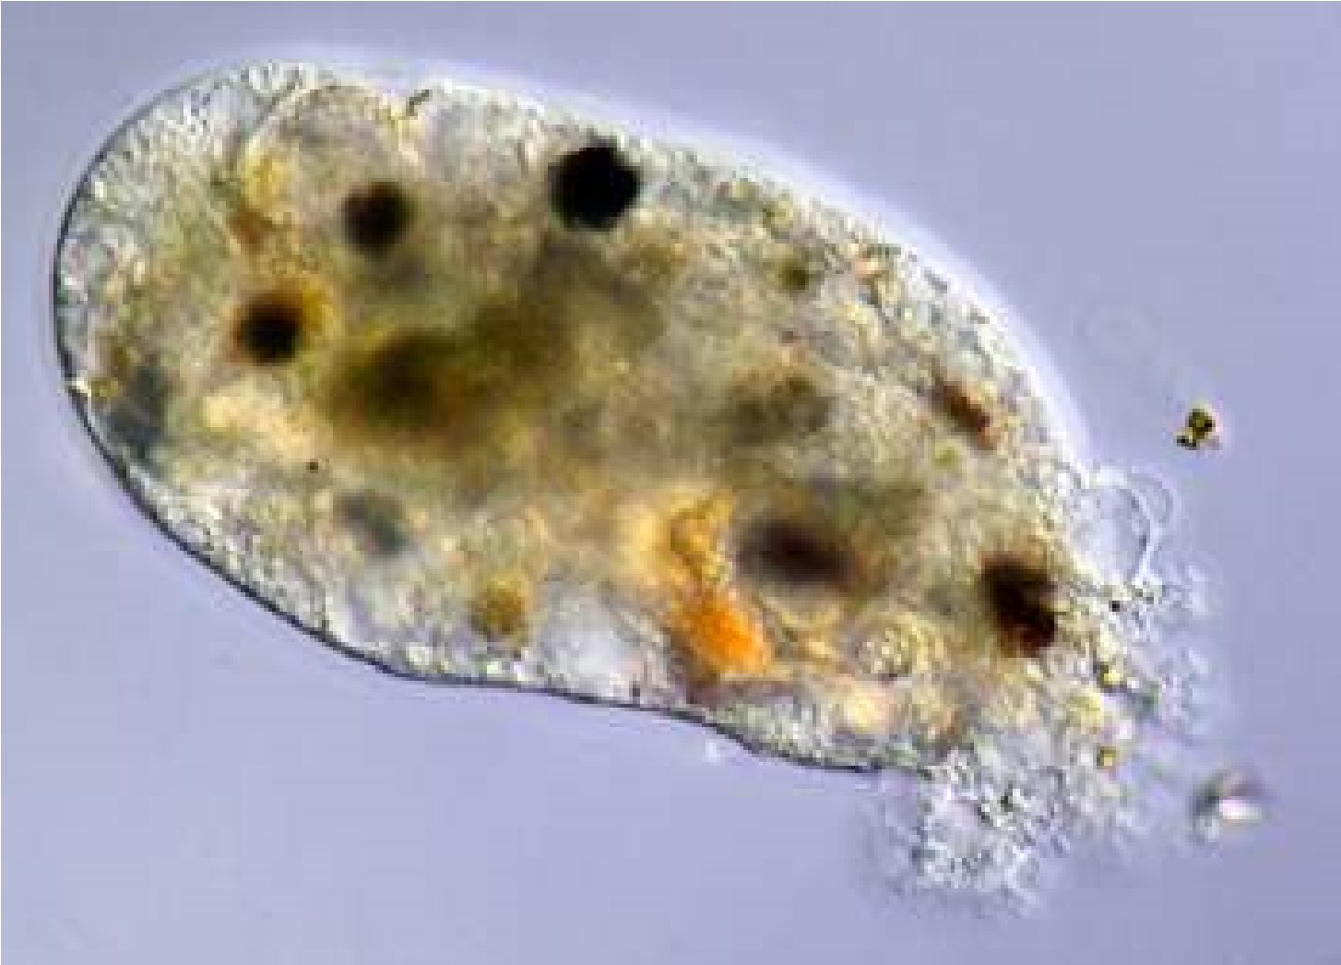

*Animation 7.3: Amoeba Source and Credit:* [*ironic*](http://www.ironic.com/P/Amoeba/)

**(b) Zoolagellates:**

These protists are mostly unicellular (a few are colonial) organisms with spherical or elongated bodies with a single central nucleus. They possess from one to many long, whip-like lagella that enable them to move. Flagellates move rapidly, pulling themselves forward by lashing lexible lagella, that are usually located at the anterior end.

Flagellates obtain their food either by ingesting living or dead organisms or by absorbing nutrients from dead or decomposing organic matter. They may be free-living, symbionts or parasites. Trichonymphas are complex, specialized lagellates with many lagella which live as symbionts in the guts of termites and help in the digestion of dry wood (Fig. 7.3a)

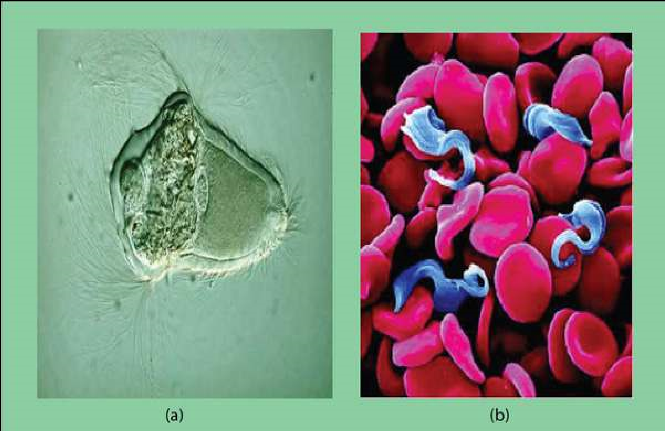

*Fig. 7.3 Zoolagellates (a) Trichonympha has hundreds of lagella (b) Trypanosoma causes sleeping sickness.*

*Animation 7.4: Paramecium Contractile Vacuole Source and Credit:* [*gif2ly*](http://www.gif2fly.com/Paramecium%20Contractile%20Vacuole.html)

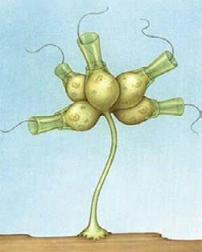Parasitic lagellates cause diseases. For example *Trypanosoma* is a human parasite causing African sleeping sickness. It is transmitted by the bite of infected tsetse ly ( Fig. 7.3 b)

Choanolagellates are sessile marine or freshwater lagellates which are attached by a stalk and their single lagellum is surrounded by a delicate collar. They are of special interest because of their striking resemblance to collar cells in sponges (Fig. 7.4).

*Fig. 7.4 A colonial choanolagellate*

### (c) Ciliates

Ciliates are unicellular organisms with a lexible outer covering called a pellicle that gives them a deinite but changeable shape. In *Paramecium*, the surface of the cell is covered with several thousand ine, short, hair-like structures called cilia. The cilia beat in such a precisely coordinated fashion that the organism can go forward, can also go back and turn around.

Some ciliates are sessile and remain attached to a rock or other surface. Their cilia set up water currents that draw food towards them. Most ciliates ingest bacteria or other tiny protists.

*Animation 7.5: Ciliates*

*Source and Credit:*

*microscopy-u*

[*k*](http://www.microscopy-uk.org.uk/mag/imagsmall/euglenamov.gif)

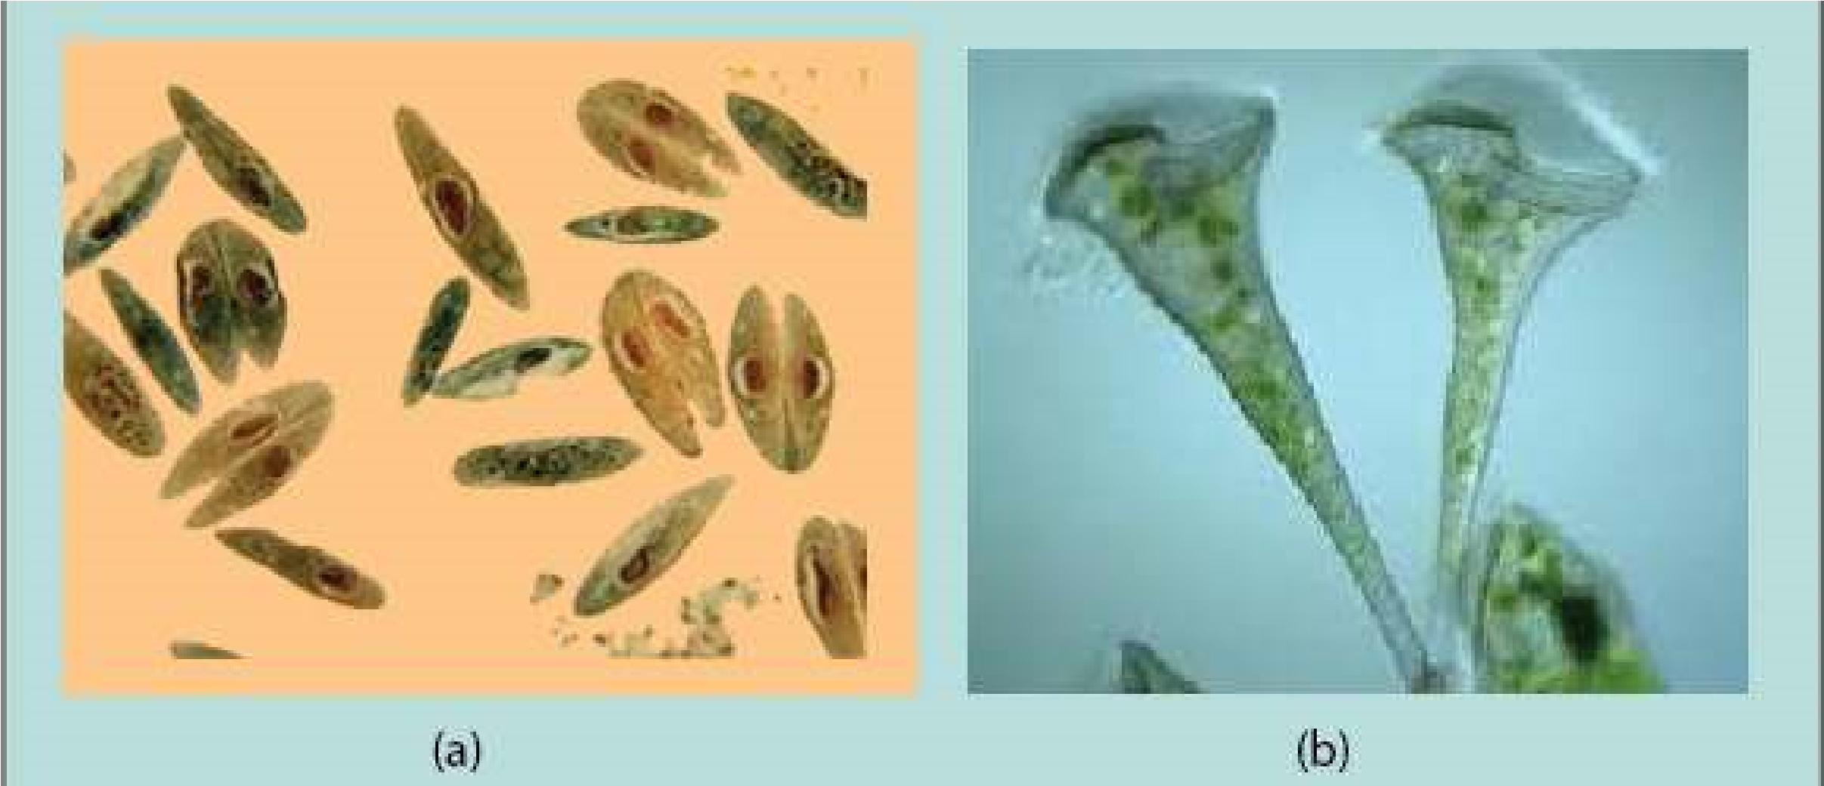

*Fig. 7.5 (a) Paramecium, conjugating individuals (b) Stentor, a sessile ciliate.*

Water regulation in freshwater ciliates is controlled by special organelles called contractile vacuoles. Ciliates difer from other protozoans in having two kinds of nuclei. One or more small diploid micronuclei that function in sexual process, and a large, polyploid macronucleus that controls cell metabolism and growth. Most ciliates are capable of a sexual process called conjugation. During conjugation two individuals come together and exchange genetic material (Fig. 7.5).

*Animation 7.6: Paramecium Reproduction Source and Credit:* [*buzzle*](http://www.buzzle.com/articles/paramecium-reproduction.html)

*Animation 7.7: Paramecium Contractile Vacuole*

*Source and Credit:*

*gif2l*

[*y*](http://www.gif2fly.com/Paramecium%20Contractile%20Vacuole.html)

### (d) Foraminiferans and Actinopods

These marine protozoans produce shells (or tests). Tests of foraminifera are made of calcium whereas those of actinopods are made of silica. The shells or tests contain pores through which cytoplasmic projections can be extended. These cytoplasmic projections form a sticky, interconnected net that entangles prey. Dead foraminiferans sink to the bottom of the ocean where their shells form a grey mud that is gradually transformed into chalk. Foraminiferans of the past have created vast limestone deposits.

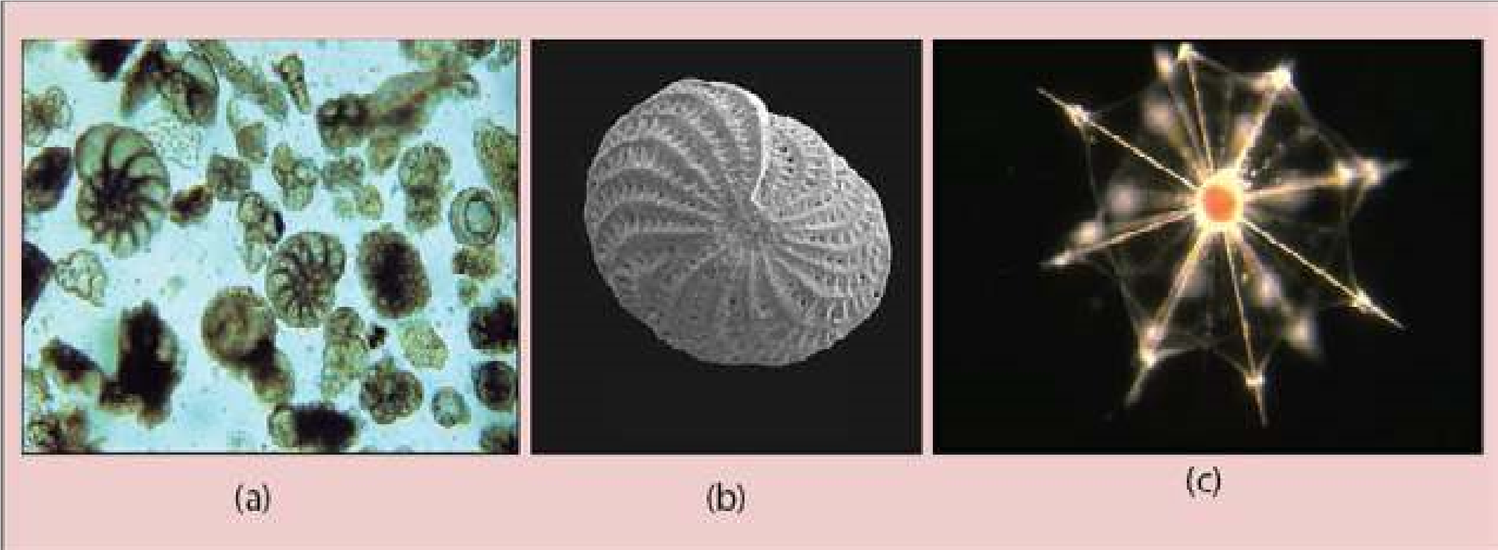

*Fig. 7.6 (a) Foraminiferan tests have (a) beautiful geometric patterns and (b) pores through which cytoplasmic projections are extended (c) Radiolarians are actinopods with glassy shells.*

### (e) Apicomplexans

Apicomplexans are a large group of parasitic protozoa, some of which cause serious diseases such as malaria in humans. Apicomplexans lack speciic structures for locomotion but move by lexing. At some stage in their lives, they develop a spore, a small infective agent transmitted to the next host. Many Apicomplexans spend part of their life in one host and part in a diferent host species

(Fig. 7.7).

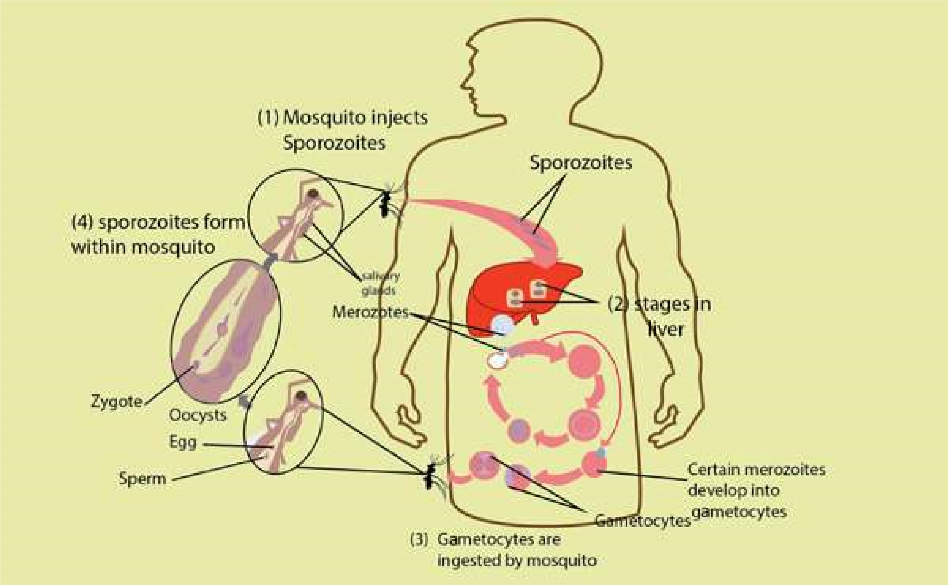

*Fig. 7.7 The life cycle of the malarial parasite (Plasmodium).*

*Plasmodium*, the apicomplexan that causes malaria, enters human blood through the bite of an infected female Anopheles mosquito. Plasmodium irst enters liver cells and then red blood cells, where it multiplies. When each infected red blood cell bursts, many new parasites are released. The released parasites infect new red blood cells, and the process is repeated. The simultaneous bursting of millions of red cells causes the symptoms of malaria; a chill, followed by high fever caused by toxic substances that are released and afect other organs of the body (Fig. 7.7).

**2. The Algae: Plan t like protists**

Algae (singular alga) are photosynthetic protists, carrying out probably 50 to 60 percent of all the photosynthesis on earth (plants account for most of the rest).

Algae difer from the plants in their sex organs which are unicellular and the zygote is not protected by the parent body. A plant zygote, on the other hand, grows into a multicellular embryo that is protected by parental tissue.

Algae exhibit a remarkable range of growth forms. Some are unicellular; others are ilamentous. Filaments are composed either of distinct cells or coenocytes (multinucleate structures that lack cross-walls), still others (e.g. seaweeds) are multicellular and intricately branched or arranged in leaf-like extensions. A body which is not diferentiated into true roots, stems and leaves and lacks xylem & phloem is called a **thallus**.

In addition to green chlorophyll a, yellow and orange carotenoids, which are photosynthetic pigments are found in all algae, other algal phyla possess a variety of other pigments (such as xanthophylls and phycoerythrin) that are also important in photosynthesis. Classiication into phyla is largely based on their pigment composition.

Algal life cycles show extreme variation, but all algae except members of the phylum Rhodophyta (red algae) have forms with lagellated motile cells in at least one stage of their life cycle.

Almost all algae are aquatic. When actively growing, algae are restricted to damp or wet environments, such as the ocean; freshwater ponds, lakes, and streams; hot springs; polar ice; moist soil, trees, and rocks. Table 7.2 summarizes the classiication of algae.

*Animation 7.8: Algae cell,*

*Source and Credit:*

*progressive-charlestow*

[*n*](http://www.progressive-charlestown.com/2014/12/link-between-lethal-disease-and-blue.html)

[**Table 7.2 Classiication of the photosynthetic Protoctists**](http://www.sabaq.pk/video-page.php?sid=sindh-biology-11th-4.4&v=b-the%20cell-29)

|  |  |  |  |  |  |
| --- | --- | --- | --- | --- | --- |
| [**Phylum**](http://www.sabaq.pk/video-page.php?sid=sindh-biology-11th-4.4&v=b-the%20cell-29) | [**Common name**](http://www.sabaq.pk/video-page.php?sid=sindh-biology-11th-4.4&v=b-the%20cell-29) | **Form** | **Locomotio**[**n**](http://www.sabaq.pk/video-page.php?sid=sindh-biology-11th-4.4&v=b-the%20cell-29) | [**Pigments**](http://www.sabaq.pk/video-page.php?sid=sindh-biology-11th-4.4&v=b-the%20cell-29) | [**Examples**](http://www.sabaq.pk/video-page.php?sid=sindh-biology-11th-4.4&v=b-the%20cell-29) |
| Euglenophyta | Euglenoid[s](http://www.sabaq.pk/video-page.php?sid=sindh-biology-11th-4.4&v=b-the%20cell-29) | Unicellular | Two lagell[a one long one short](http://www.sabaq.pk/video-page.php?sid=sindh-biology-11th-4.4&v=b-the%20cell-29) | [Chl. *a*, Chl. *b* Carotenoids](http://www.sabaq.pk/video-page.php?sid=sindh-biology-11th-4.4&v=b-the%20cell-29) | [*Euglena*](http://www.sabaq.pk/video-page.php?sid=sindh-biology-11th-4.4&v=b-the%20cell-29) |
| [Pyrrophyta](http://www.sabaq.pk/video-page.php?sid=sindh-biology-11th-4.4&v=b-the%20cell-29) | Dinolagellates | Unicellular | Two lagell[a](http://www.sabaq.pk/video-page.php?sid=sindh-biology-11th-4.4&v=b-the%20cell-29) | [Chl. *a*, Chl. *c*](http://www.sabaq.pk/video-page.php?sid=sindh-biology-11th-4.4&v=b-the%20cell-29)  [Carotenes including Fucoxanthin](http://www.sabaq.pk/video-page.php?sid=sindh-biology-11th-4.4&v=b-the%20cell-29) | [*Gonyaulax, Ceratium*](http://www.sabaq.pk/video-page.php?sid=sindh-biology-11th-4.4&v=b-the%20cell-29) |
| Chrysophyta | Diatom[s](http://www.sabaq.pk/video-page.php?sid=sindh-biology-11th-4.4&v=b-the%20cell-29) | [Usually unicellular](http://www.sabaq.pk/video-page.php?sid=sindh-biology-11th-4.4&v=b-the%20cell-29) | [Usually none](http://www.sabaq.pk/video-page.php?sid=sindh-biology-11th-4.4&v=b-the%20cell-29) | [Chl. *a*, Chi. *c*](http://www.sabaq.pk/video-page.php?sid=sindh-biology-11th-4.4&v=b-the%20cell-29)  [Carotenes including Fucoxanthin](http://www.sabaq.pk/video-page.php?sid=sindh-biology-11th-4.4&v=b-the%20cell-29) | [*Diatoma,*](http://www.sabaq.pk/video-page.php?sid=sindh-biology-11th-4.4&v=b-the%20cell-29)  [*Frequilaria*](http://www.sabaq.pk/video-page.php?sid=sindh-biology-11th-4.4&v=b-the%20cell-29)  [*Pinnularia*](http://www.sabaq.pk/video-page.php?sid=sindh-biology-11th-4.4&v=b-the%20cell-29) |
| Phaeophyta | Brown alga[e](http://www.sabaq.pk/video-page.php?sid=sindh-biology-11th-4.4&v=b-the%20cell-29) | Multicellular | Two lagell[a on](http://www.sabaq.pk/video-page.php?sid=sindh-biology-11th-4.4&v=b-the%20cell-29)  [reproductive cells](http://www.sabaq.pk/video-page.php?sid=sindh-biology-11th-4.4&v=b-the%20cell-29) | [Chl. *a*, Chl. *c*](http://www.sabaq.pk/video-page.php?sid=sindh-biology-11th-4.4&v=b-the%20cell-29)  [Carotenes including Fucoxanthin](http://www.sabaq.pk/video-page.php?sid=sindh-biology-11th-4.4&v=b-the%20cell-29) | [*Fucusi*](http://www.sabaq.pk/video-page.php?sid=sindh-biology-11th-4.4&v=b-the%20cell-29)  [*Macrocvstis*](http://www.sabaq.pk/video-page.php?sid=sindh-biology-11th-4.4&v=b-the%20cell-29) |
| Rhodophyta | Red algae | Multicellula[r or unicellular](http://www.sabaq.pk/video-page.php?sid=sindh-biology-11th-4.4&v=b-the%20cell-29) | None | Chl. [*a*,](http://www.sabaq.pk/video-page.php?sid=sindh-biology-11th-4.4&v=b-the%20cell-29)  [carotenes Phycoerythrin](http://www.sabaq.pk/video-page.php?sid=sindh-biology-11th-4.4&v=b-the%20cell-29) | [*Chondrus*](http://www.sabaq.pk/video-page.php?sid=sindh-biology-11th-4.4&v=b-the%20cell-29)  [*Polysiphonia*](http://www.sabaq.pk/video-page.php?sid=sindh-biology-11th-4.4&v=b-the%20cell-29) |
| Chlorophyta | Green alga[e](http://www.sabaq.pk/video-page.php?sid=sindh-biology-11th-4.4&v=b-the%20cell-29) | [Unicellular, colonial, multicellular](http://www.sabaq.pk/video-page.php?sid=sindh-biology-11th-4.4&v=b-the%20cell-29) | [Most have lagella](http://www.sabaq.pk/video-page.php?sid=sindh-biology-11th-4.4&v=b-the%20cell-29) | [Chl. *a*, Chl. *b*. carotenes](http://www.sabaq.pk/video-page.php?sid=sindh-biology-11th-4.4&v=b-the%20cell-29) | [*Chlorella,*](http://www.sabaq.pk/video-page.php?sid=sindh-biology-11th-4.4&v=b-the%20cell-29)  [*Ulva,*](http://www.sabaq.pk/video-page.php?sid=sindh-biology-11th-4.4&v=b-the%20cell-29)  [*Acetabularia*](http://www.sabaq.pk/video-page.php?sid=sindh-biology-11th-4.4&v=b-the%20cell-29)  [*Spirogyra*](http://www.sabaq.pk/video-page.php?sid=sindh-biology-11th-4.4&v=b-the%20cell-29) |

*Animation 7.9: Euglena*

[*m*](http://www.sabaq.pk/video-page.php?sid=sindh-biology-11th-4.4&v=b-the%20cell-29)

*Source and Credit:*

*microscopy-*

[*u*](http://www.microscopy-uk.org.uk/mag/imagsmall/euglenamov.gif)

[*k*](http://www.microscopy-uk.org.uk/mag/imagsmall/euglenamov.gif)

### (I) The Euglenoids

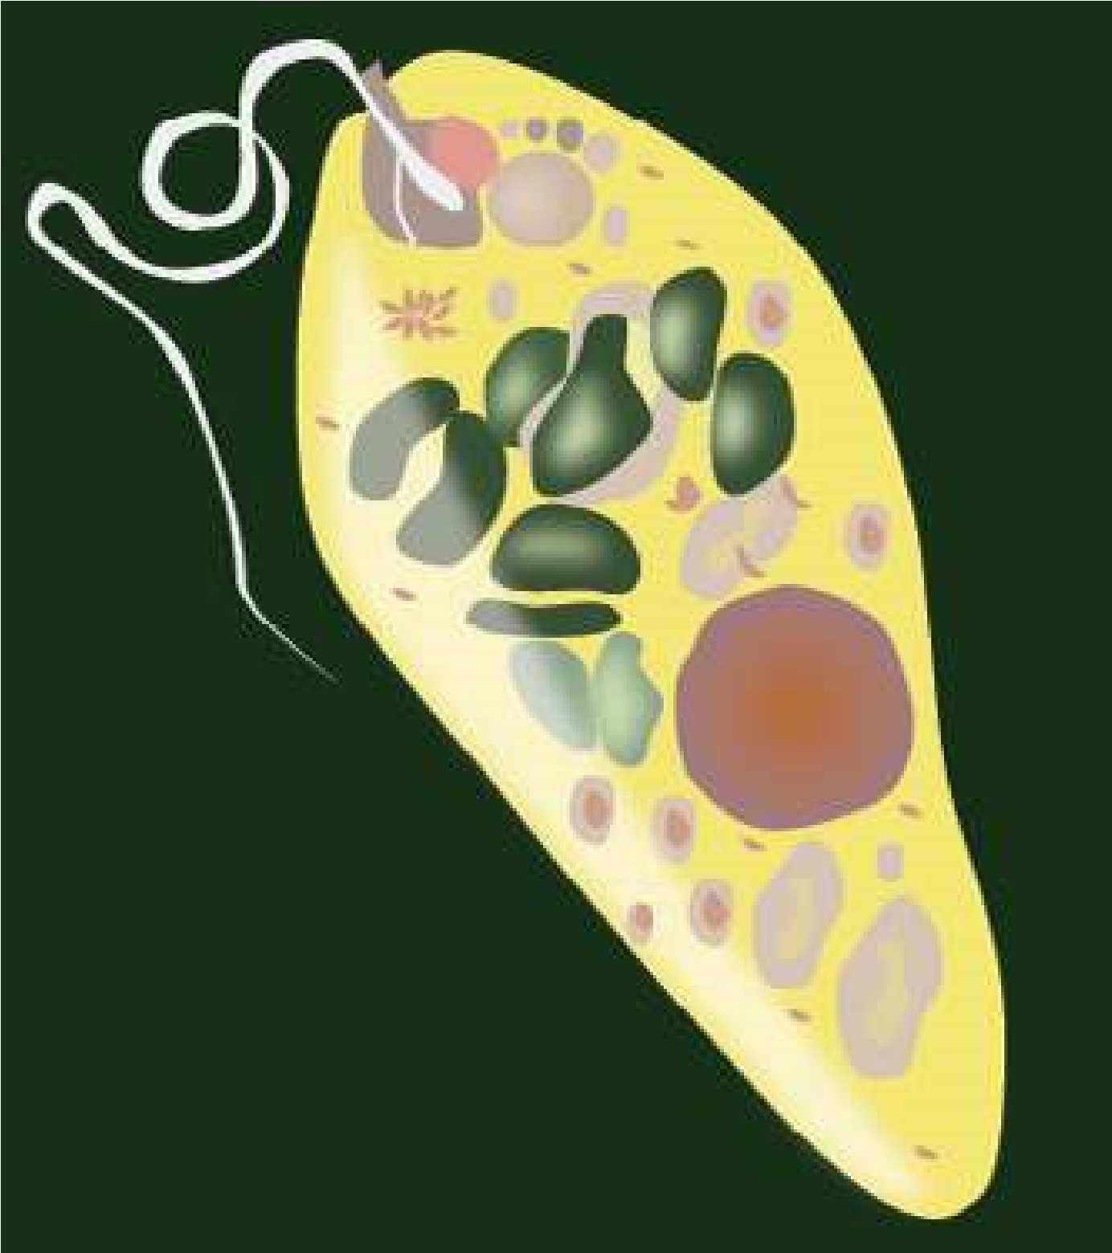*Euglenoids* have at various times been classiied in the plant kingdom (with algae) and in animal kingdom (in protozoans). Based on molecular data, euglenoids are thought to be closely related to zoolagellates. They are plant like in their pigments. However, some photosynthetic euglenoids lose their chlorophyll when grown in dark and obtain their nutrients heterotrophically by ingesting organic matter. Other species of euglenoids are always colourless and heterotrophic (Fig.

7.8).

Fig 7.8 : Euglenoids have special evolutionary signiicance as they resemble with plants and green algae in having similar pigments and, on the other hand, are also related One of the most unusual protist to zoolagellates.

*Animation 7.10: Euglenoids,*

*Source and Credit:*

*gifsou*

[*p*](http://stream1.gifsoup.com/view4/3492627/euglenoids-movement-o.gif)

*Animation 7.11: Euglenoids*

*Source and Credit:*

*sgprotist.iles.wordpres*

[*s*](https://sgprotist.files.wordpress.com/2011/08/euglena-whipping.gif)

### (ii) Dinolagellates

One of the most unusual protist phyla is that of dinolagellates. Most dinolagellates are unicellular. Their cells are often covered with shells of interlocking cellulose plates impregnated with silicates.

Ecologically, dinolagellates are one of the most important groups of producers (second only to diatoms) in marine ecosystem. Dinolagellates are known to have occasional population explosions or blooms. These blooms frequently colour the water orange, red or brown and are known as red tides (Fig. 7.9).

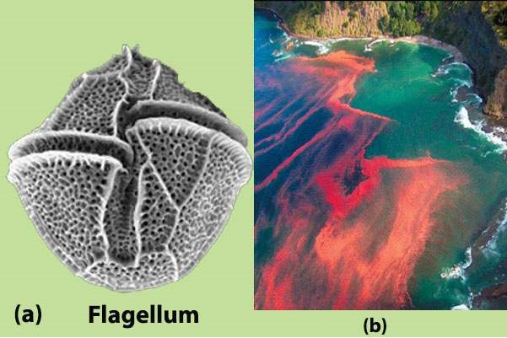

*Fig. 7.9 (a) A dinolagell ate showing cellulose plates in the shell and lagella located in the grooves, (b) A red tide.*

*Animation 7.12: Dinolagellates*

*Source and Credit:*

*microscopy-u*

[*k*](http://www.microscopy-uk.org.uk/mag/imgsep01/per1.gif)

#### (iii) Diatoms

The cell wall of each diatom consists of two shells that overlap where they it together, much like a petri dish. Silica is deposited in the shell, and this glasslike material is laid down in intricate patterns.

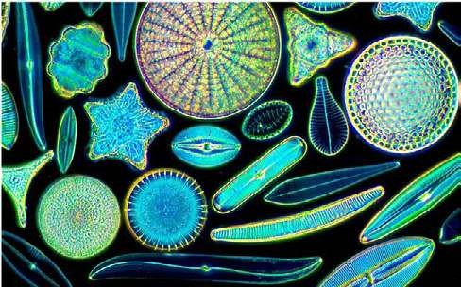

*Fig. 7.10 Diatoms have silica shells with extremely beautiful symmetrical patterns*

Diatoms are the major producers in the aquatic (marine and freshwater) ecosystems because of their extremely large numbers. Diatoms are very important in aquatic food chains (Fig. 7.10).

*Animation 7.13: Diatoms*

*Source and Credit:*

*49*

*.media.tumb*

[*l*](https://49.media.tumblr.com/81ef20ee51352fcd08a0ba5219bb7703/tumblr_nlq18xeOJi1qhgo13o3_400.gif)

*Animation 7.14: Diatoms*

*Source and Credit:*

*ininity-us*

[*a*](http://infinity-usa.com/Products/InFocus/photos/Diatoms-Pleurax.gif)

### (iv) Brown Algae

Brown algae include the giants of the protist kingdom. All brown algae are multicellular and range from a few centimeters to approximately 75 meters in length. The largest brown algae, called the kelps are tough and leathery in appearance. They possess lealike blades, stemlike stipes, and rootlike anchoring holdfast. Brown algae are common in cooler marine waters, especially along rocky coastlines in the intertidal zone (Fig. 7.11).

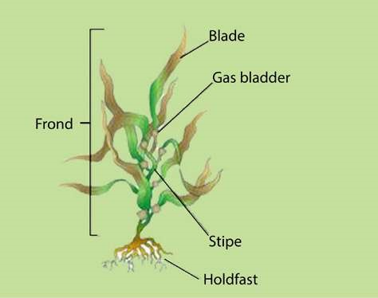

*Fig. 7.11 Laminaria, a brown alga showing blades, stipes and holdfast*

**(**

**v) Red Algae**

The multicellular body form of red algae is commonly composed

of complex interwoven ilaments that are delicate and feathery. A

few red algae are lattened sheets of cells. Most multicellular red

algae attach to rocks or other substances by a basal holdfast. Some

red algae incorporate calcium carbonate in their cell walls from the

ocean and take part in building coral reefs alongwith coral animals

(

Fig.

7.12).

*Animation 7.15: Brown algae*

*Source and Credit:*

*easterncapescubadivin*

[*g*](http://www.easterncapescubadiving.co.za/downloads/brown%20algae.gif)

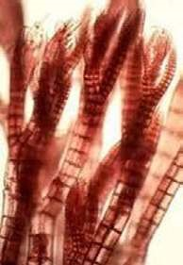

*Fig.*

*7.12*

*Polysiphonia*

*is*

*a*

*representative red alga with world*

*wide distribution*

*Animation 7.16: Red Algae*

*Source and Credit:*

*easterncapescubadivin*

[*g*](http://www.easterncapescubadiving.co.za/downloads/red%20algae.gif)

*Animation 7.17: Red Algae*

*Source and Credit:*

*makeagi*

[*f*](http://makeagif.com/GuAKoF)

### (vi) Green Algae

Green algae have pigments, energy reserve products, and cell walls that are identical to those of plants. Green algae are photosynthetic, with chlorophyll a, chlorophyll b, and carotenoids present in the chloroplasts. Their main energy reserves are stored as starch. Most green algae possess cell walls with cellulose. Because of these and other similarities it is generally accepted that plants arose from ancestral green algae. Evidence from RNA sequencing also indicates that green algae and the plants form a monophyletic lineage (Fig. 7.13).

*Animation 7.18: Green Algae*

*Source and Credit:*

*easterncapescubadivin*

[*g*](http://www.easterncapescubadiving.co.za/downloads/red%20algae.gif)

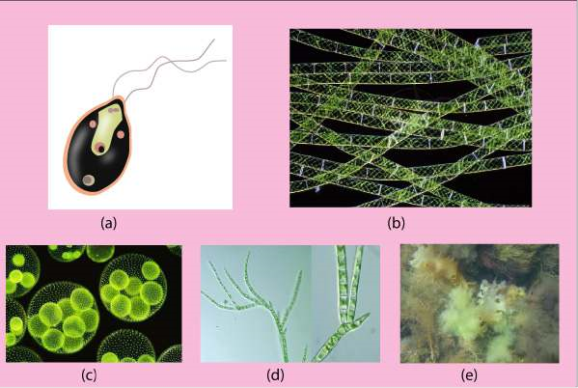

*Fig. 7.13 Green algae exhibit diverse forms, (a) Unicellular Chlamydomonas (b) Desmids have cells with two halves. (c) Colonial Volvox (d) Filamentous Spirogyra (e) Ulva, having sheet like body.*

|  |  |  |
| --- | --- | --- |
|  | |  | | --- | | *Chlorella* is a unicellular non-motile green alga. Its habitat is fresh water ponds and ditches. It is easily cultured and has been used as an experimental organism in research on photosynthesis as well as being investigated as an alternate source of food. | |

#### Importance of Algae

Algae have great economic and environmental importance for us. Some algae such as kelps are edible and may be used to overcome shortage of food in the world. Marine algae are also source of many useful substances like algin, agar, carrageenan, and antiseptics. Algae are major producers of the aquatic ecosystem, thus they play a basic role in food chains, providing food and oxygen to other organisms.

## 3. FUNGUS-LIKE PROTISTS

Some protists supericially resemble fungi in that they are not photosynthetic and some have bodies formed of threadlike structures called hyphae. However, funguslike protists are not fungi for several reasons. Many of these protists have centrioles and produce cellulose as a major component of their cell walls, whereas fungi lack centrioles and have cell walls of chitin. Two major groups of fungus-like protists are : Slime molds and water molds (oomycotes).

### (i) Slime molds or Myxomycota

The feeding stage of a slime mold is a plasmodium, a multinucleate mass of cytoplasm that can grow to 30 cm (1 ft) in diameter. The plasmodium, which is slimy in appearance, streams over damp,

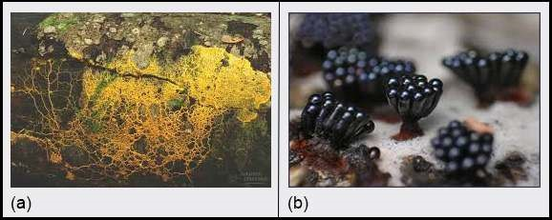

*Fig. 7.14 Slime mold* **Physarum** *(a) The plasmodium is a naked mass of cytoplasm having many nuclei. (b) Reproductive structures are stalked sporangia.*

decaying logs and leaf litter. It often forms a network of channels that cover a large surface area. As it creeps along, it ingests bacteria, yeasts, spores and decaying organic matter (Fig. 7.14).

During unfavourable condition, slime mold forms resistant haploid spore by meiosis within stalked structures called sporangia. When conditions become favourable again, spores germinate into bilagellated or amoeboid reproductive or swarm cells which unite to form diploid zygote. Zygote produces multinucleate plasmodium, each nucleus being diploid.

The plasmodial slime mold *Physarum polycephalum* is a model organism that has been used to study many fundamental biological processes, such as growth and diferentiation, cytoplasmic streaming, and the function of cytoskeleton.

*Animation 7.19: Slime mould*

*Source and Credit:*

*49*

*.media.tumb*

[*l*](https://49.media.tumblr.com/2b258b58fa18bf41f339283f2bdebb5a/tumblr_n3fkr6Dowp1twfgiio1_500.gif)

*Animation 7.20: Slime mold physarum*

*Source and Credit:*

*waynesword.paloma*

[*r*](http://waynesword.palomar.edu/images/phystr1.gif)

#### Water molds or Oomycotes

Oomycotes show close relations with the fungi and have a similar structure, but are now regarded as more ancient group. Their cell walls contain cellulose, not chitin. Their hyphae are aseptate (without cross walls). Oomycotes include a number of pathogenic organisms, including ***Phytophthora infestans***, which have played infamous roles in human history.

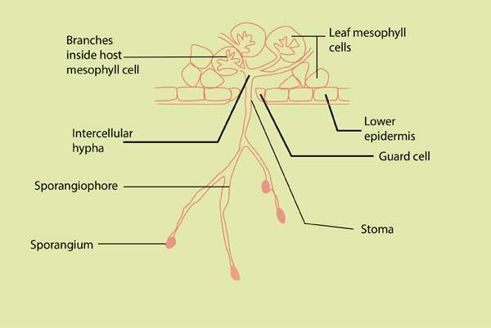

*Fig. 7.15 Phytoplithora infestans growing in a diseased potato leaf, with sporangiophores emerging from the underside of the leaf.*

*Phytophthora infestans* was the cause of Irish potato famine of the 19th century. It causes a disease commonly known as late blight of potatoes. Because of several rainy, cool summers in Ireland in the 1840’s, the water mold multiplied unchecked, causing potato tubers to rot in the ields. Since potatoes were the staple of Irish peasants’ diet, many people (250,000 to more than 1 million) starved to death. The famine prompted a mass migration out of Ireland to such countries as the United States (Fig. 7.15).

### EXERCISE

**Q.1. Short Questions**

Write two characteristics of each of the following groups:

(i) Protozoa (ii) Dinolagellates (iii) Diatoms (iv) Slime molds (iv) Oomycetes

**Q.2. Extensive question.**

1. Discuss important features of protists. Why are protists so diicult to classify?
2. What are the reasons for grouping simple eukaryodc organisms into a separate kingdom, protista?

1. How are protists important to humans? What is their ecological importance?
2. What are three major groups of protists?
3. Discuss general characteristics of algae.
4. Green algae are considered ancestral organisms of green land plants. Discuss.
5. What features distinguish Oomycotes from fungi?
6. Describe structure and reproduction of slime molds.

CHAPTER

8 Fungi

# The Kingdom Of

Recyclers

1

[*Source & Credit: u*](http://anatomyeshs.wikispaces.com/Ch.16+Respiratory+System)*Animation 8.1: Kingdom Fungi*[*nifyingprinciplesofbiology*](http://unifyingprinciplesofbiology.com/index_shows/fungi.gif)

Approximately 100,000 species of organisms called “**fungi**” are known and many more are estimated to be present. This group includes notorious pathogens such as disastrous rusts, smuts of wheat and com, and molds found growing on important crops and foodstuf. Delicacies such as mushrooms, trules and morels, and other organisms of commercial use such as *Penicillium* - the source of antibiotic penicillin, and the **yeasts** - used in bakeries and breweries are also members of this group. Ecological role of fungi as decomposers is paralleled only by bacteria.

Taxonomic status of fungi has changed from that of ‘a group of Plant kingdom’ to a separate kingdom “Fungi”. They resemble plants in some respects - have cell wall, lack centrioles and are non-motile. But fungi resemble more animals than plants. Unlike plants and like animals, fungi are heterotrophs, lack cellulose in their cell wall and contain **chitin** - the chemical found in external skeleton of **arthropods**. For this reason, some **mycologists** (scientists who study fungi) think that fungi and animals probably arose from a common ancestor. But fungi are diferent from animals in having cell wall, being absorptive heterotrophs and non-motile. So fungi are neither plants nor animals. Their DNA studies also conirm that they are diferent from all other organisms. They show a characteristic type of mitosis, called ‘**nuclear mitosis**’. During nuclear mitosis, nuclear envelope does not break; instead the mitotic spindle forms within the nucleus and the nuclear membrane constricts between the two clusters of daughter chromosomes. (In some fungi nuclear envelope dismantles late). Because fungi are distinct from plants, animals and protists in many ways, they are assigned to a separate kingdom **‘Fungi’.**

## THE BODY OF FUNGUS

The body of a fungus, called **mycelium**, consists of long, slender, branched tubular thread like filaments called the **hyphae** (singular **hypha**). Hyphae spread extensively over the surface of substratum. Chitin in their wall is more resistant to decay than are cellulose and **lignin** which make up plant cell wall. Hyphae may be septate or non-septate. **Septate** hyphae are divided by cross-walls called **septa** (singular septum) into individual cells containing one or more nuclei. Nonseptate hyphae lack septa and are not divided into individual cells; instead these are in the form of an elongated multinucleated large cell. Such hyphae are called **coenocytic** hyphae, in which cytoplasm moves effectively, distributing the materials throughout. Septa of many septate fungi have a pore through which cytoplasm flows from cell to cell, carrying the materials to growing tips and enabling the hyphae to grow rapidly when food and water are abundant and temperature is favourable. All parts of fungus growing through the substrate are metabolically active. Extensive spreading system of hypae provides enormous surface area for absorption.

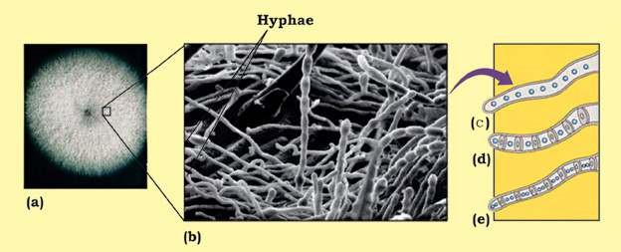

*Fig 8.1 The fungus body plan : (a) Fungus mycelium growing on agar plate (b) Hyphae of mycelium (c) A coenocytic hypha (d) A septate hypha with porous septa and monokaryotic cells (e) A septate hypha with dikaryotic cell.*

Hyphae may be packed together and organized to form complex *A single mycelium may produce upto* reproductive structures such as mushrooms, puf balls, morels etc. *a kilometer of new hyphae in only one* which can expand rapidly. Yeast are non-hyphal unicellular fungi. *day. A circular clone of Armillaria, apathogenic fungus alicting conifers, growing out from a central focus, has* All fungal nuclei are **haploid** except for transient **diploid zygote** *been measured upto 15 hectares (1hectare = 10000 m2). Could it be the* that forms during sexual reproduction. *world’s largest organism?*

## NUTRITION IN FUNGI

All fungi lack chlorophyll and are heterotrophs (obtaining carbon and energy from organic matter). They obtain their food by direct absorption from the immediate environment and are thus **absorptive heterotrophs**. Most fungi are **saprotrophs** (or **saprobes**), **decomposers** that obtain their food (energy, carbon and nitrogen) directly from dead organic matter. They secrete out digestive **enzymes** which digest dead organic matter, and the organic molecules thus produced are absorbed back into the fungus. Saprobic fungi anchor to the substrate by modiied hyphae, the **rhizoids**. Fungi are the principal decomposers of cellulose and lignin, the main components of plant cell walls (most bacteria cannot break them). Extensive system of fast growing hyphae provides enormous surface for absorptive mode of nutrition. Saprobic fungi, alongwith bacteria, are the major decomposers of the biosphere, contributing to the recycling of the elements (C, N, P, 0, H etc) used by living things.

Some fungi are **parasites**, some are even **predators**, and still others are **mutualists**. **Parasitic** fungi absorb nutrients directly from the living host cytoplasm with the help of special hyphal tips called **haustoria**. They may be obligate or facultative. Obligate parasites can grow only on their living host and cannot be grown on available deined growth culture medium. Various **mildews** and most rust species are obligate parasites. **Facultative parasites** can grow parasitically on their host as well as by themselves on artiicial growth media.

Some fungi are active **predators**. The oyster mushroom (*Pleurotus ostreatus*) is an omnivorous (predatory) fungus. It paralyses the nematodes (that feed on this fungus), penetrate them, and absorb their nutritional contents, primarily to fulil its nitrogen requirements. It fulills its glucose requirements by breaking the wood. Some species of *Arthrobotrys* trap soil nematodes by forming **constricting ring,** their hyphae invad and digest the unlucky victim. Other predators have other adaptations, such as secretion of sticky substances.

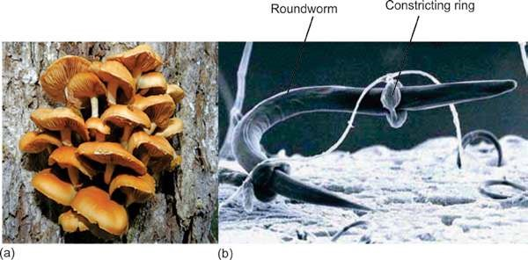

*Fig 8.2 Carnivorous fungi (a) The osyter mushroom decomposes wood, and also uses nematodes as a source of nitrogen (b) A nematode is trapped in constricting ring of a soil - dwelling carnivorous fungus* ***(Arthrobotrys sp.)****.*

Fungi form two key mutualistic symbiotic associations (associations of beneit to both partners). These are **lichens** and **mycorrhizae**.

**Lichens** are mutualistic symbiotic associations between certain fungi (mostly Ascomycetes and imperfect fungi, and few Basidiomycetes - about 20 out of 15000 species of lichens) and certain photoautotrophs-either green algae or a cyanobacterium, or some times both. Most of the visible part of lichen consists of fungus, and algal components are present within the hyphae (Fig 8.3). Fungus protects the algal partner from strong light and desiccation and itself gets food through the courtesy of alga.

Lichens can grow at such places where neither of the components alone can, even at harsh places such as bare rocks etc. Lichens vary in colour, shape, overall appearance, growth form (Fig 8.3).

They are ecologically very important as bioindicators of air pollution.

*Video 8.2: Fungal network*

*Source and Credit:*

*pmb.ox.a*

[*c*](http://www.pmb.ox.ac.uk/fellows-staff/profiles/professor-mark-fricker)

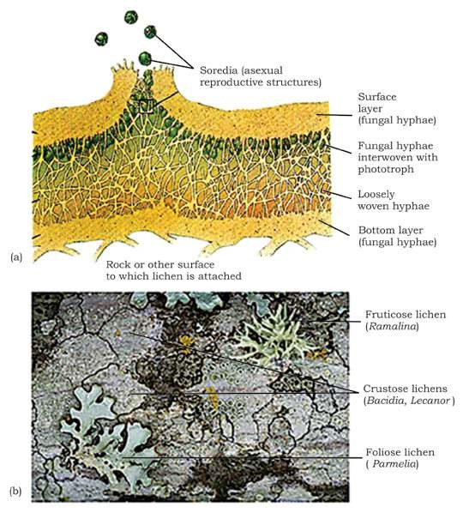

*Fig 8.3 Lichens (a) Cross section of a typical lichen showing diferent layers, (b) Diferent types of lichens varying in size, colour and appearance. Three growth forms - crustose grow tightly attached to rocks, tree trunks etc; foliose are leaf - like, fruticose are branching.*

**Mycorrhizae** are mutualistic association between certain fungi and roots of vascular plants (about 95% of all kinds of vascular plants). The fungal hyphae dramatically increase the amount of soil contact and total surface area for absorption and help in the direct absorption of phosphorus, zinc, copper and other nutrients from the soil into the roots. Such plants show better growth than those without this association. The plant, on the other hand, supplies organic carbon to fungal hyphae.

There are two main types of mycorrhizae (Fig 8.4): **endomycorrhizae**, in which the fungal hyphae penetrate the outer cells of the plant root, forming coils, swellings, and minute branches, and also extend out into surrounding soil; and **ectomycorrhizae**, in which the hyphae surround and extend between the cells but do not penetrate the cell walls of the roots. These are mostly formed with pines, irs etc. However, the mycelium extends far out into the soil in both kinds of mycorrhizae.

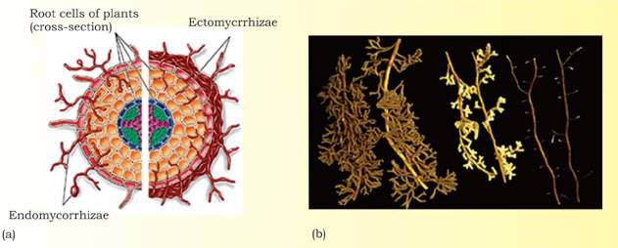

*Fig 8.4 Endomycorrhizae and ectomycorrhizae. (a) In endomycorrhiza (left side of igure), fungal hyphae penetrate and branch out in a root cells. In ectomycorrhiza (right side of igure), fungal hyphae simply grow around but do not penetrate the root cell (b) Ectomycorrhizae on roots of pines.*

Fungi grow best in moist habitats, but are found wherever organic matter is present. They survive dry conditions in some resting stage or by producting resistant spores. They can also tolerate a wide range of pH from 2 - 9, a wide temperature range, and high osmotic pressure such as in concentrated salt/sugar solutions as in jelly, jam etc. These features also help them in their survival on land. Fungi store surplus food usually as lipid droplets or glycogen in the mycelium.

## REPRODUCTION

Most fungi can reproduce asexually as well as sexually (except imperfect fungi in which sexual reproduction has not been observed).

### Asexual reproduction

**Asexual reproduction** takes place by spores, conidia, fragmentation, and budding. **Spores** are produced inside the reproductive structures called **sporangia**, which are cut of from the hyphae by complete septa. Spores may be produced by sexual or asexual process, are haploid, non-motile and not needing water for their dispersal, are small, produced in very large number and dispersed by wind to great distances and cause wide distribution of many kinds of fungi, including many plant pathogens. When spores land in a suitable place, they germinate, giving rise to new fungal hyphae. Spores may also be dispersed by insects and other small animals and by rain splashes. Spores are a common means of reproduction in fungi.

Conidia (singular conidium) are non- motile, asexual spores which are cut of at the end of modiied hyphae called **conidiophores**, and not inside the sporangia, usually in chains or clusters. These may be produced in a very large number, can survive for weeks and cause rapid colonization of new food.

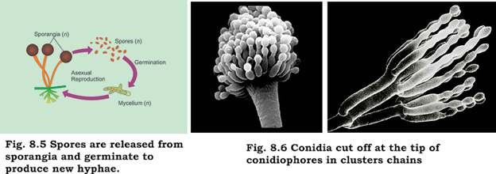

**Fragmentation** is simple breaking of mycelium of some hyphal fungi, each broken fragment giving rise to a new mycelium.

Unicellular yeasts reproduce by **budding** (an asymmetric division in which tiny outgrowth or bud is produced which may separate and grow (Fig 8.7), or by simple, relatively equal cell division.

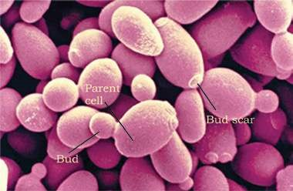

*Fig. 8.7 Micrograph shows yeast (Saccharomyces cerevisiae) in various stages of budding.*

## Sexual Reproduction

Details of sexual reproduction vary in diferent groups of fungi but fusion of haploid nuclei and meiosis are common to all. When fungi reproduce sexually, hyphae of two genetically diferent but compatible mating types come together, their cytoplasm fuse followed by nuclear fusion. In two of the three main groups of fungi (Basidiomycetes, Ascomycetes), fusion of nuclei (**karyogamy**) does not take place immediately after the fusion of cytoplasm (**plasmogamy**); instead the two genetic types of **haploid** nuclei from two individuals may coexist and divide in the same hyphae for most of the life of the fungus. Such a fungal hypha/cell having 2 nuclei of diferent genetic types is called **dikaryotic** (also **heterokaryotic**) hypha/cell (Fig. 8.1).

Diferent groups of fungi produce diferent types of haploid sexual spores, such as **basidiospores** and **ascospores**, subsequent upon meiosis in zygote. These spores may be produced by their characteristic structure/fruiting bodies such as **basidia/basidiocarps** and **asci/ascocarps**.

## CLASSIFICATION OF FUNGI

Classiication of fungi into four main groups is based primarily on the type of their sexual reproductive structures and methods of reproduction. However, these groups also difer in the type of hyphae and some other characters (Table 8.1).

**Table 8.1 Classiication of Fungi**

|  |  |  |  |  |
| --- | --- | --- | --- | --- |
| **Phylum (group) Typical examples Sexual reproduction** | | | **Asexual reproduction** | **Hyphae** |
| Zygomycota (Zygomycetes) | *Rhizopus*, (Black bread mold)  *Pilobolus* (spitting fungus) | Zygospores | Non-motile spores form in sporangia | Nonseptate, multi nucleate |
| Ascomycota (Ascomycetes or sac - fungi) | Yeasts, morels, trules, powdery mildews,molds | Ascospores  inside sac-like asci | Conidia cut of from tips of  conidiophores | Septate, lengthy dikaryotic phase. |
| Basidiomycota (Basidiomycetes or club-fungi) | Mushrooms, rusts, Basidiospores smuts, pufballs, borne on club bracket fungi shaped basidia | | Uncommon | Septate, lengthy dikaryotic phase |
| Deuteromycota *Aspergillus,* Sexual phase  (Deuteromycetes/ *Penicillium,* has not been  Imperfect fungi) *Altemaria* observed | | | Conidia | Varied |

### Zygomycota (Zygomycetes or Conjugating Fungi)

During their sexual reproduction, zygote formed directly by the fusion of hyphae forms temporary, dormant, thick walled resistant structure called zygospore, hence the name Zygomycetes. Meiosis takes place when zygospore germinates and haploid spores are produced. Spores on germination produce new mycelium. Asexual reproduction by spores is common. Hyphae are coenocytic.

Example: Rhizopus, found growing on spoiling moist bread, fruit etc.

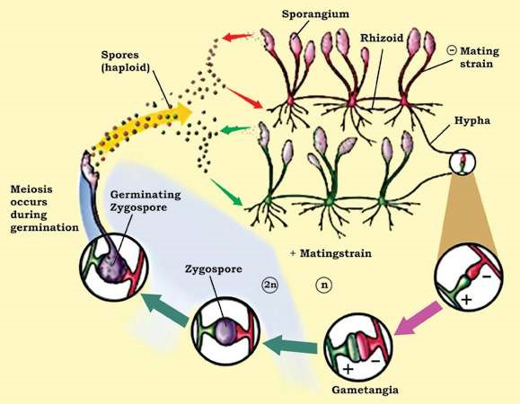

*Fig. 8.8 Life cycle, of Rhizopus (black bread mold), a Zygomycete. Zygote formed by fusion, of gametangia directly develops into a resting zygospore.*

### Ascomycota (Ascomycetes or Sac - Fungi)

It is the largest group of fungi, including over 60,000 species, 50% or so occurring in lichens and some, such as morels, are mycorrhizal. Most are terrestrial, though some are marine or fresh water. The group shows diversity from unicellular yeasts to large cup fungi and morels. They produce haploid sexual spores called **ascospores** by meiosis inside their characteristic sac like structures called **asci** (sing.ascus). Meiosis follows nuclear fusion inside the ascus, commonly 8 ascospores are produced inside each ascus. Most sac-fungi have asci inside macroscopic fruiting bodies called **ascocarps**-the visible morels etc. Their hyphae are septate. They have lengthy dikaryotic phase that forms ascocarps. They reproduce asexually by conidia that are often dispersed by wind.

**Yeasts** are unicellular microscopic fungi, derived from all the three diferent groups of fungi but mostly Ascomycetes, and reproducing mostly asexually by budding (Fig. 8.7).

However yeasts reproduce sexually by forming asci/ascospores or basidia/basidiospores. They ferment carbohydrate (glucose) to ethanol and carbondioxide. Because of this feature and many other reasons, these are of great economic importance (see economic importance of fungi). *Saccharomyces cerevisiae* is the most commonly exploited yeast.

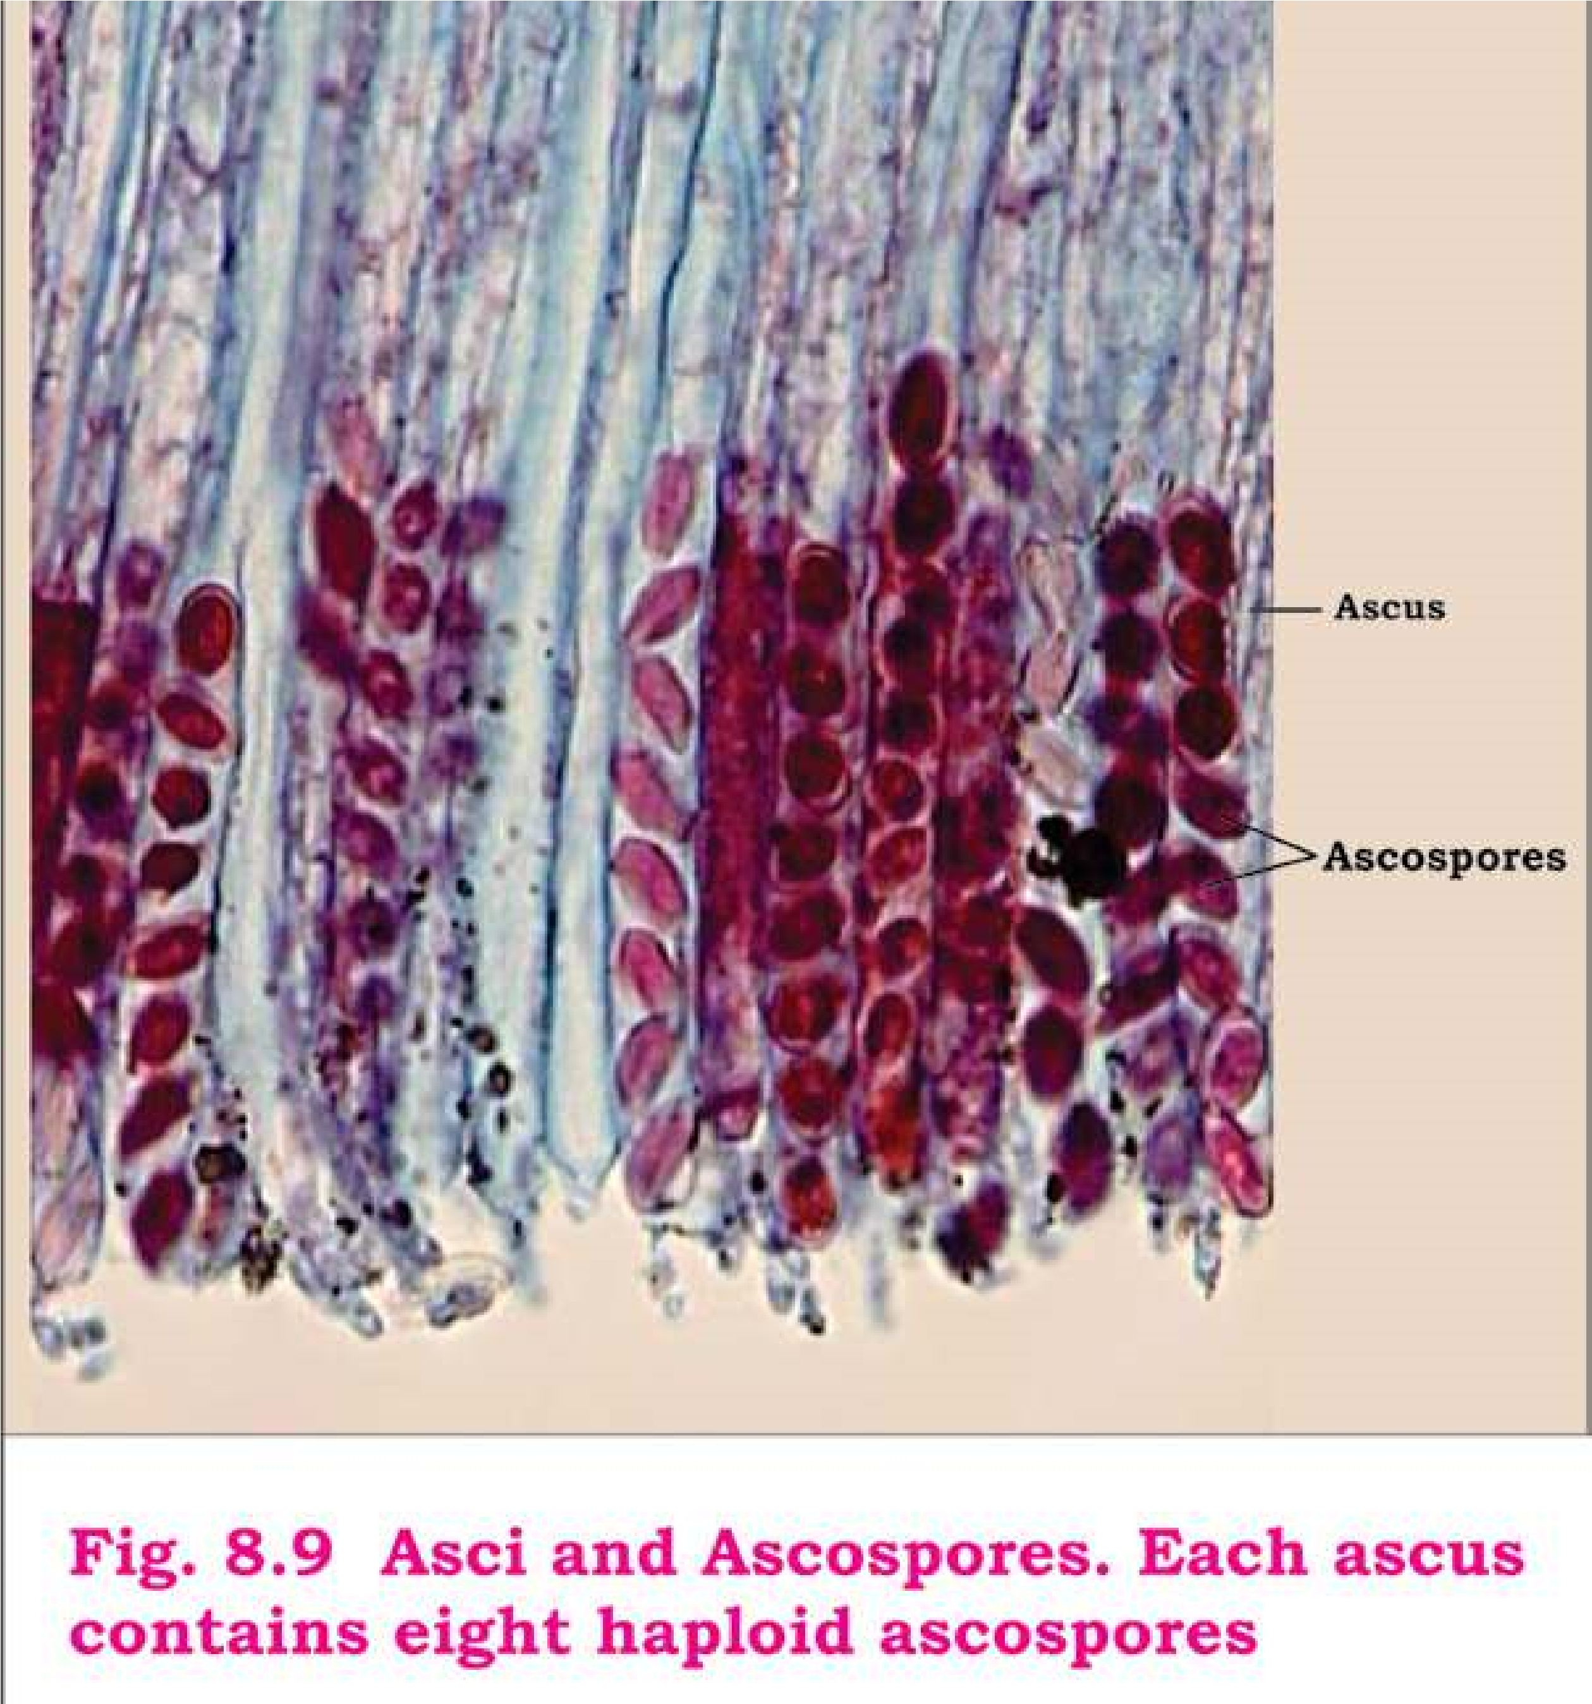

### Basidiomycota (Basidiomycetes or Club - Fungi)

These are among the most familiar fungi; edible mushrooms, devastating plant pathogens rusts and smuts, pufballs, and bracket/shelf fungi are all club fungi. Basidiomycetes are named so for their characteristics, club-shaped (hence also called club fungi) sexual reproductive structure, the **basidium** (plural **basidia**). Nuclear fusion in the basidium is followed by meiosis.

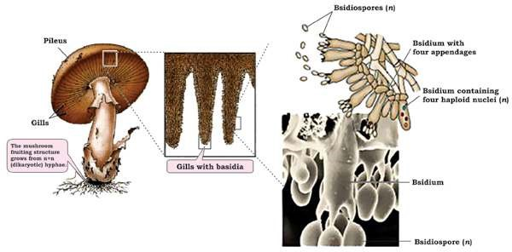

*Fig. 8.10 Basidiomycetes. A mushroom’s fruiting structures. The gills on underside of mushroom’s cap are lined with basidia, on which basidiospores are produced.*

Four haploid sexual spores, called the **basidiospores**, are born on, not inside, each basidium. During most **Rusts** are called so because of numerous part of their life cycle the hyphae are septate; the cells rusty, orange-yellow coloured disease are uninucleate during one phase, and binucleate spots on their host surface (mostly stem, (dikaryotic) during the remaining, lengthy phase. Their leaves), later revealing brick/rust-red characteristic fruiting bodies, or visible mushrooms, spores of the fungus. **Smuts** are called are formed entirely of dikaryotic mycelium. **Puccinia** so because of their black, dusty spore species are most common rust fungi, and **Ustilago** masses that resemble soot or smut; species most common smut fungi. these spore masses replace the grain

kernels such as those of wheat, corn etc.

(Fig. 8.11, 8.15)

Spores (teliospores) of *Ustilago tritici* (loose smut of wheat) are carried by wind from infected wheat ears to healthy lowers, where they germinate. The resulting hyphae penetrate lower ovaries. Inside the ovary mycelium spreads and becomes dormant and remains so in the seed (grain). When such infected seeds are sown next season, the hyphae also grow within the growing plant and form smut spores inside the kernel, thus destroying them completely. The covering of the grain breaks exposing the black spores mass, that may be dispersed by wind (Fig. 8.11)

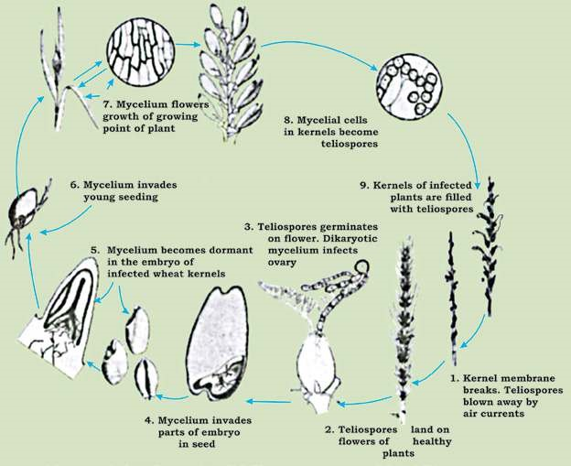

*Fig. 8.11: Disease cycle of loose smut of wheat caused by a club - fungus (Ustilago tritici)*

### Deuteromycota (Deuteromycetes or Imperfect Fungi)

This heterogenous group includes all such fungi in which sexual phase has not been observed. Most of them are related to their sexually reproducing relatives of Ascomycetes; however some are related to other two phyla (Zygomycota, Basidiomycota) as well. If sexual structures are found on an imperfect fungus, it is then reassigned to the appropriate phylum. Biologists now can classify most imperfect fungi on the basis of DNA sequences, though sexual structures may not be found.

*Penicillium* (blue, green molds), *Aspergillus* (brown molds), *Alternaria, Fusarium, Helminthosporium* are some of the economically important genera of Deuteromycetes (see economic importance of fungi).

**Penicillium** sp. (blue, green molds) are wide spread saprotrophic species common on decaying fruit, bread etc. Its hyphae are septate. *Penicillium* reproduces asexually by means of naked spores called **conidia**. These are found in chains at the tips

of special hyphae called **conidiophores**, which are *Despite absence of sexual reproduction, imperfect fungishow special kind of genetic recombination, called* branched. Brush-like arrangement of its conidia is **parasexuality,** *in which portions of chromosomes of* characteristic of *Penicillium* (Fig. 8.12). These conidia *two nuclei lying in the same hypha are exchanged.* give colour to the mycelial colony, which is circular.

Mature conidia are easily and readily dispersed.

*Animation 8.3: Moldy Peach*

*Source and Credit:*

*wikipedi*

[*a*](https://en.wikipedia.org/wiki/Mold)

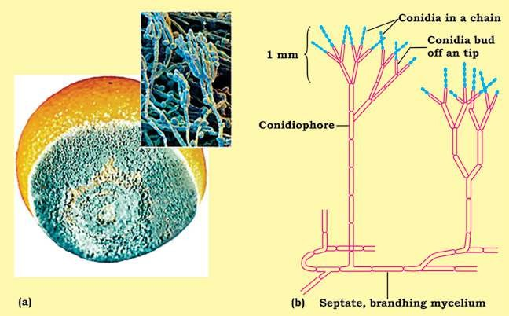

*Fig. 8.12 Penicillium (a) A moldy orange; the blue mold is caused by saprobic species of Penicillium. (b) Penicillium showing asexual reproduction, characteristic brush-like arrangement of conidia.*

## LAND ADAPTATIONS OF FUNGI

Fungi; although grow best in moist habitats, are found wherever organic matter is present. They are a successful group of land organisms, and posses several features in their body and reproduction that adapt them to their habit and terrestrial mode of life.

Extensive system of fast-spreading hyphae penetrate the substrate and enormously increase the contact and surface area for absorption. Cytoplasmic low throughout the hyphae is responsible for their rapid growth and spread. Chitin in their thickened hyphal wall is more resistant to decay than are cellulose and lignin found in plant cell wall. They can even break down the lignin (in addition to cellulose) to obtain their nutrients. In saprobes, certain modiied hyphae called **rhizoids** anchor the fungus to the substrate and also digest and then absorb the food.

They are very well adapted to live on land due to lack of lagellated cells, nonmotile spores and conidia eicient dispersal by wind, thick-walled zygote and other resistant structures. Hyphae may be modiied in such a way as to enable them to reproduce themselves without dependence on external water.

Many fungi are more tolerant than are bacteria to damage in hyperosmotic surroundings. Many can tolerate temperature extremes - 5°C below freezing and 50°C or more. Now you can tell why molds (e.g. *Penicillium*) can grow on oranges and jelly kept in a refrigerator, while generally bacteria cannot.

## IMPORTANCE OF FUNGI

### Ecological Importance

Fungi have great ecological impact. They are very important as decomposers and symbionts. Fungi, along with saprobic bacteria, play vital role in the recycling of inorganic nutrients in the ecosystem. Without their activity all the essential nutrients would soon become locked up in the mounds of dead animals, plants, would be unavailable for use by organisms, and life would cease. Mycorrhizal fungi improve the growth of plants with which they are associated. 95% of all kinds of vascular plants have this association.

Lichens growing on rocks break them, setting stage for other organisms during the course of ecological succession. Lichens are very good bioindicators of air quality as they are very sensitive to pollution. Some fungi are also used for bioremediation (degrading/removing environmental poisons/pollutants by organisms).

**Commercial Importance**

Fungi cause economic gains as well as losses.

### Economic gains due to fungi

1. Certain fungi are edible. About 200 species of mushrooms (e.g. Agaricus sp), morels (e.g. Morchella esculenta), trules (underground fruiting bodies of some

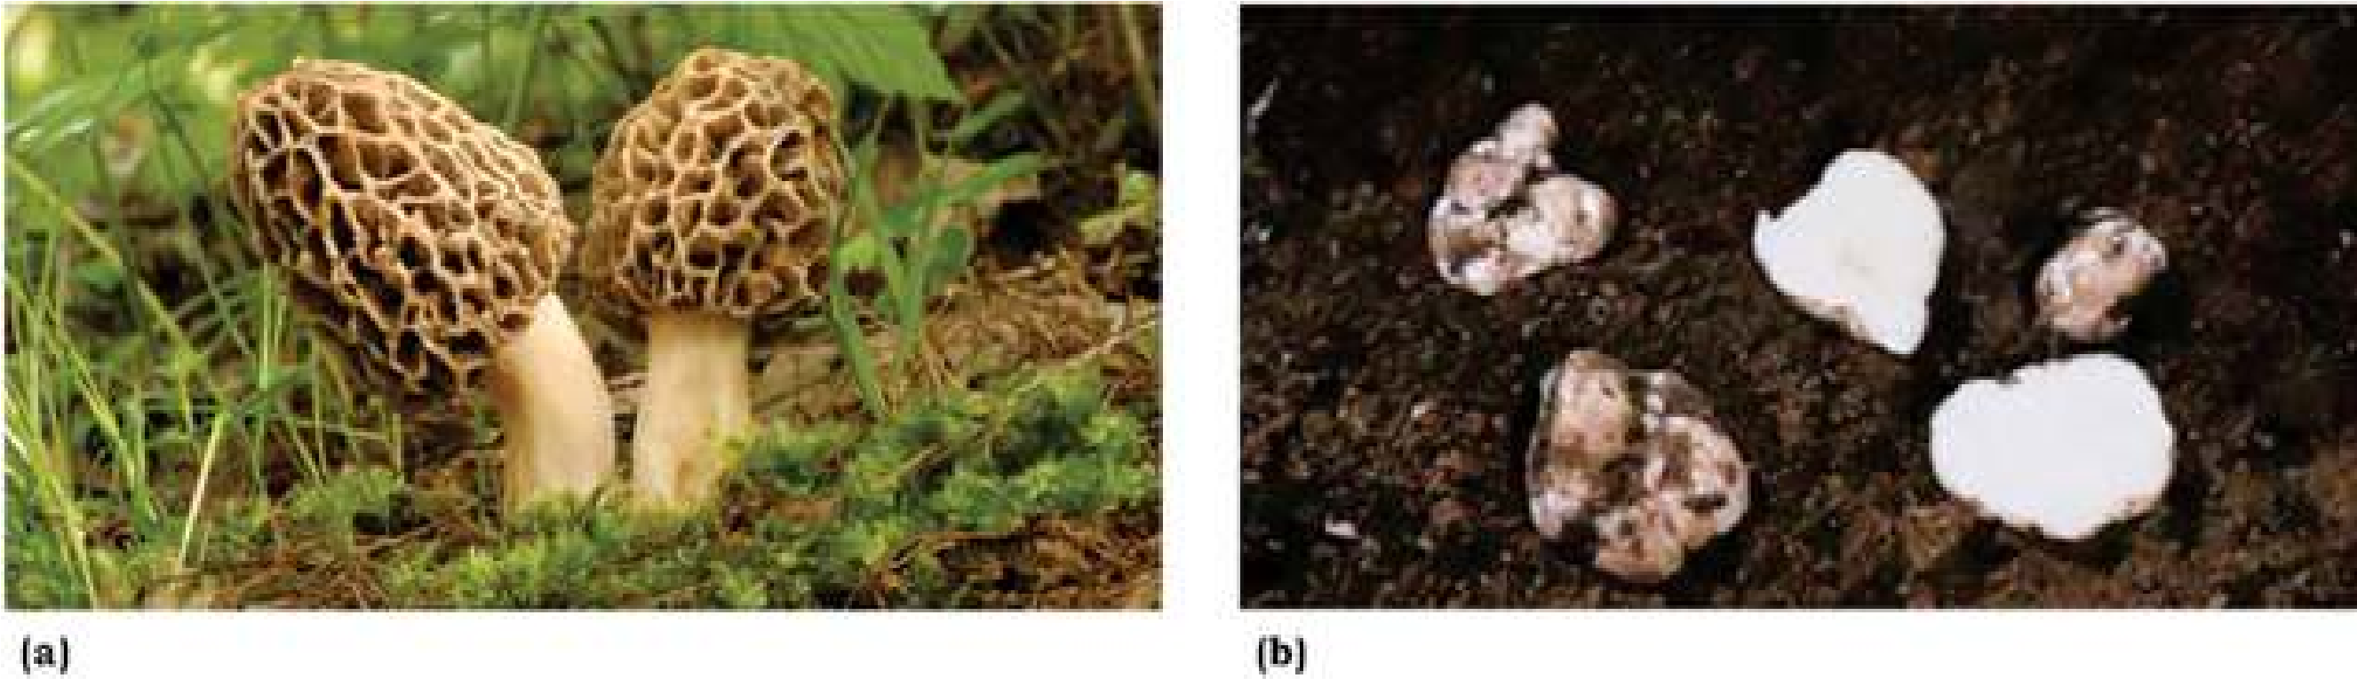

*Fig. 8.13 Edible fungi (a) A common morel (Morchella esculenta). (b) The trules (Tuber species) are underground fruiting bodies that people ind with the help of trained dogs or pigs.*

Ascomycetes, e.g. *Tuber* sp) are common edible fungi. Beware of poisonous mushrooms called the **toadstools**, such as death cap/death angel (*Amanita*) and jack-O’ latem mushroom (Fig. 8.14).

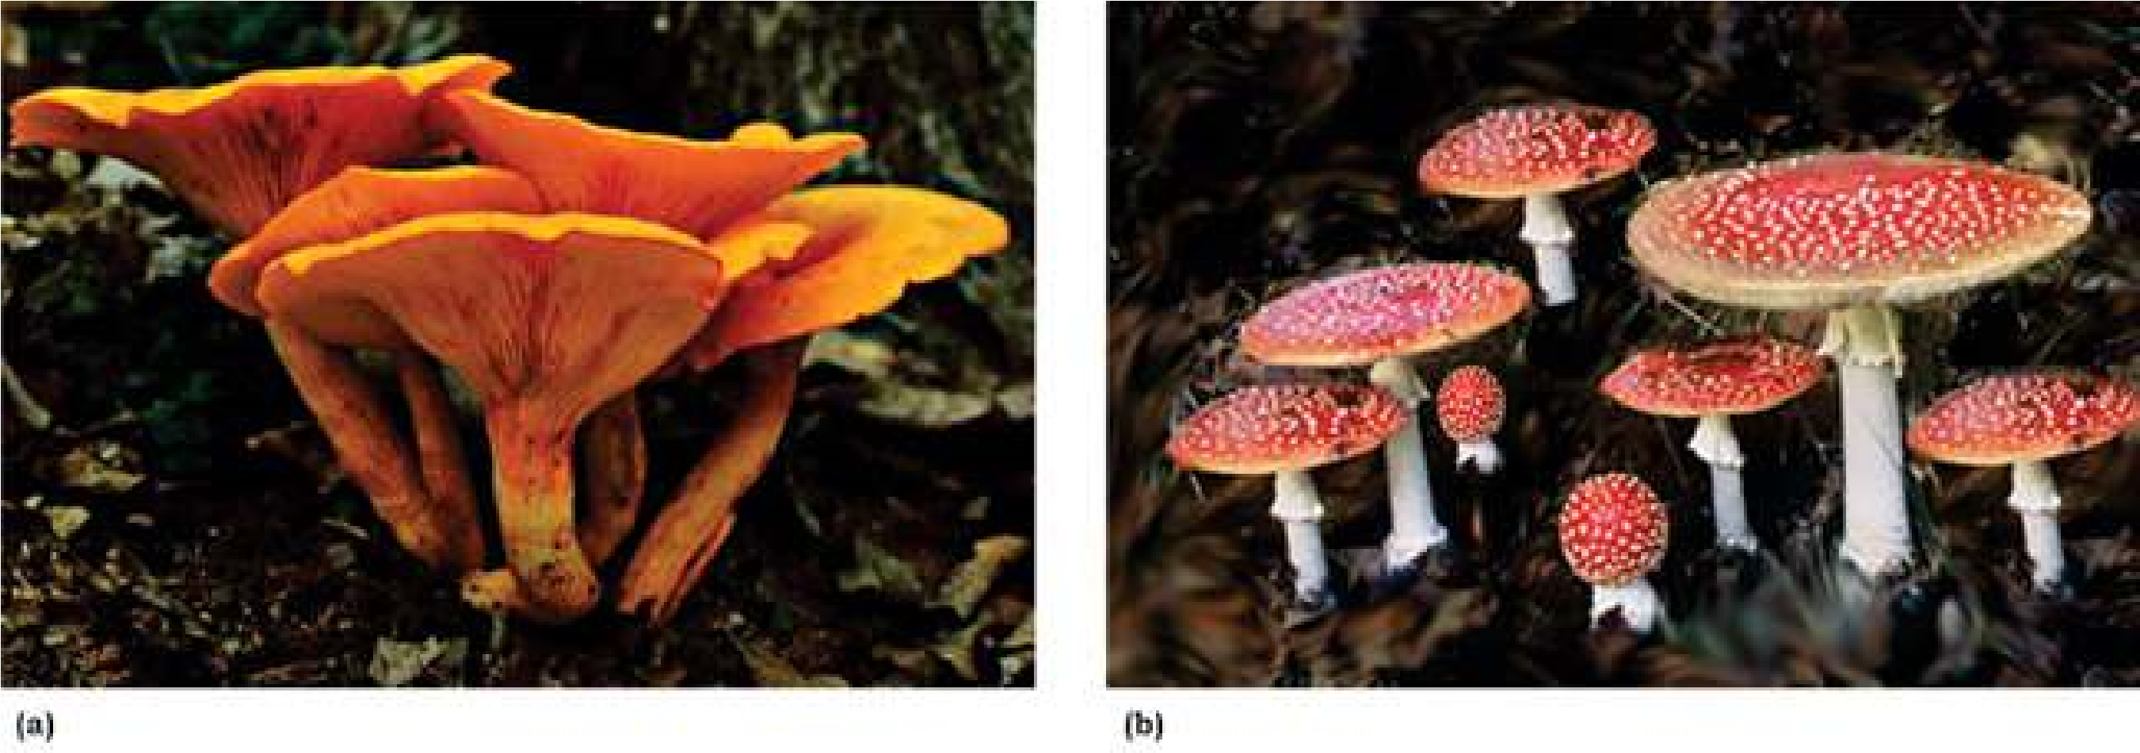

*Fig. 8.14 a: Poisonous mushroom Jack-O’ lantern (Omphalotus olearius) whose gills glow in the dark, b: Amanita, another common poisonous mushroom.*

Reindeer moss (a lichen, not a moss) is used as food for reindeers and some other large animals in arctic/subarctic/boreal regions.

1. Certain fungi are used in food industry. Because of their fermenting ability, yeasts (*Saccharomyces cerevisiae*) are used in the production of bread and liquor. *Penicillium* species are used for giving lavour, aroma and characteristic colour to some cheese. Some species of Aspergillus are used for fermenting/producing soya sauce and soya paste from soya bean. Citric acid is also obtained from some *Aspergillus* species.
2. Some fungi are source of antibiotics and some other drugs. *Penicillin*, irst antibiotic to be ever discovered (by A. Fleming-1928) is obtained from *Penicillium notatum*. Lovastatin is used for lowering blood cholestrol; cyclosporine obtained from a soil fungus is used in organ transplantation forpreventing transplant rejection; and ergotine to relieve one kind of headache migraine. Griseofulvin is used to inhibit fungal growth.
3. Some natural dyes obtained from lichens are used in textile industry.
4. Yeasts are heavily used in genetic/molecular biological research because of their rapid generation and rapidly increasing pool of genetic and biochemical information. Yeast were the irst eukaryotes to be used by genetic engineers. In 1983, a functional artiicial chromosome was made in *Saccharomyces cervisiae.* The same yeast was the irst eukaryote whose genomic sequence was completely studied in 1996. Yeasts are also being investigated for production of some hormones. Pink bread mold *Neurospora* has also been used for genetic research.

#### Economic losses due to Fungi

1. Fungi are responsible for many serious plant diseases because they produce several enzymes that can breakdown cellulose, lignin and even cutin. All plants are susceptible to them. Extensive damages due to rusts and smut diseases of wheat, com (Fig. 8.15) and rice prompted mass displacement, and starvation to death of many people.

**Powdery mildews** (on grapes, rose, wheat etc), **ergot of rye, red rot of sugar cane, Potato wilt, cotton root rot, apple scab**, and **brown rot** of peaches, plums, apricots and cherries are some other common plant diseases caused by fungi.

1. 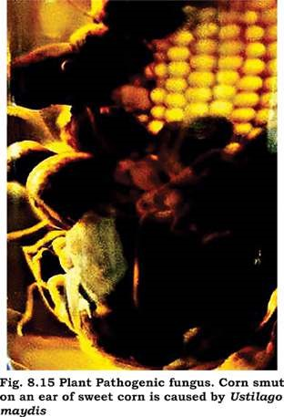Fungi also cause certain animal diseases. **Ringworm** and **athlete’s foot** are supericial fungal infections caused by certain imperfect fungi. *Candida albicans,* a yeast, causes oral and vaginal thrush (*Candidasis* or *candidosis*). **Histoplasmosis** is a serious infection of lungs caused by inhaling spores of a fungus which is common in soil contaminated with bird’s feces. If infection spreads into blood stream and then to other organs (which is very occassional), it can be serious and even fatal. *Aspergillus fumigatus* causes **aspergillosis**, but only in persons with defective immune system such as AIDS, and may cause death. Some strains of *Aspergillus* produce one of the most carcinogenic (cancer-causing) mycotoxins (toxins produced by fungi), called **alatoxins**. *Aspergillus* contaminates improperlystored grains such as peanuts and com etc. Milk, eggs and meat may also have small traces of alatoxins. Any moldy human food or animal forage product should be discarded. **Ergotism** is caused by eating bread made from purple ergot-contaminated rye lour. The poisonous material in the ergot causes nervous spasm, convulsion, Psychotic delusion and even gangrene.
2. Saprobic fungi are not only useful recyclers but also cause incalculable damage to food, wood, iber, and leather by decomposing them. 15-50% of world’s fruit is lost each year due to fungal attack. Wood-rotting fungi destroy not only living trees but also structural timber. Bracket/ shelf fungi (Fig. 8.16) cause lot of damage to stored cut lumber as well as stands of timber of living trees.

A pink yeast ( *Rhodotorula)* on shower curtains and other moist surfaces.

*Video 8.4: Mushrooms Fungi*

*Source and Credit:*

*reblogg*

[*y*](http://rebloggy.com/post/trippy-tree-shrooms-psychedelic-hiking-caps-mushrooms-fungi-psychedelics-fungus/36737065967)

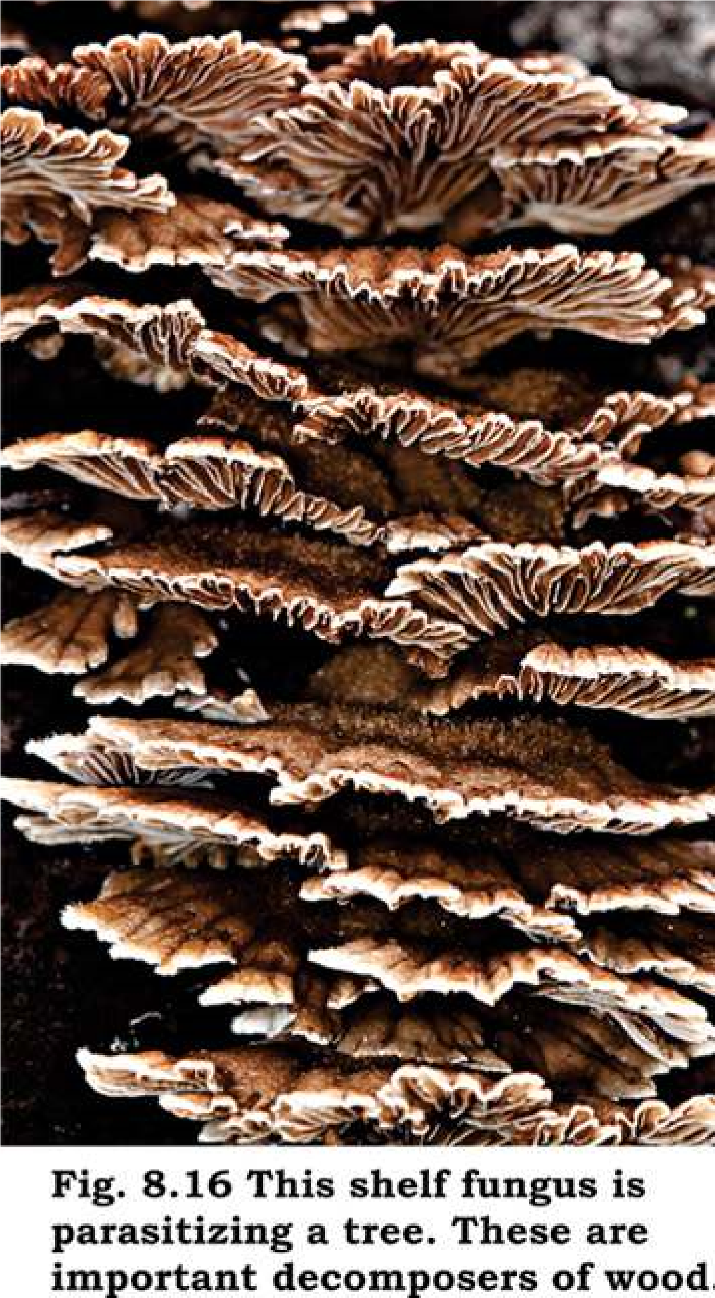

### EXERCISE

1. **.1. Short questions**
   1. What is a hypha? What is the advantage of having incomplete septa?
   2. What is the composition of fungal cell wall and how is this composition advantageous to fungi?
   3. To which phyla do yeasts belong? How do they difer from other fungi?
   4. Name sexual and asexual spores of Ascomycetes.
   5. What are mycorrhizae?
   6. By what means can individuals in imperfect fungi be classiied?
   7. Give a single characteristic that diferentiates Zygomycota from Basidiomycota.
   8. Why is green mold more likely to contaminate an orange kept in a refrigerator than are bacteria?
   9. What is a fungus?
   10. State two parallel characteristics of Ascomycetes and Basidiomycetes.

**Q.2. Extensive questions**

* 1. Discuss taxonomic status of fungi.
  2. Summarise diferentiating/distinguishing characteristics of four main groups of Fungi, and give two common examples of each group.
  3. State various features of fungi that adapt them to terrestrial mode of life.
  4. What is ecological importance of saprotrophic fungi, of lichens and mycorrhizae? (v) Same enzymes of fungi are useful on one hand and harmful on other.

Discuss.

* 1. Name any four important fungal diseases of plants and four fungal diseases of humans, and briely describe any one of the plant diseases and any one of the diseases of humans.
  2. Describe, giving examples, diferent ways in which fungi are useful to humans.
  3. Diferentiate between the members of each of the following pairs.
     1. Spore/Conidium (b) Ascus/Basidium
     2. Dikaryotic/Diploid (c) Ascocarp/Ascus
     3. Obligate parasite/Facultative parasite
     4. Endomycorrhizae/Ectomycorrhizae
     5. Plasmogamy/Karyogamy